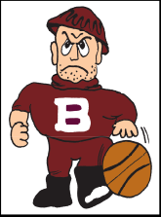
Bangor Slaters Men’s Basketball Offseason Strength & Agility Program

Block I: 5 Weeks - March 31st to May 1st
DAY 2
Plate Squats: Press w/ Weight Plate
vs.

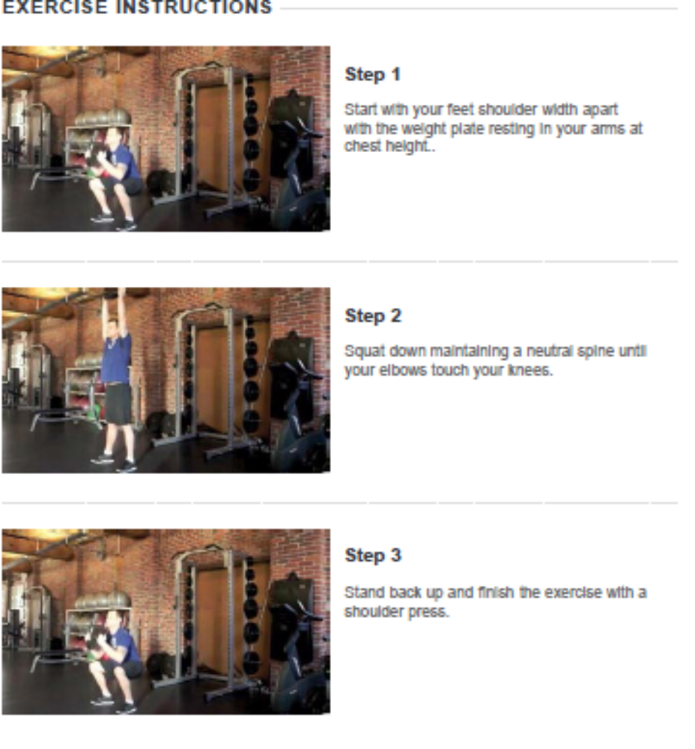
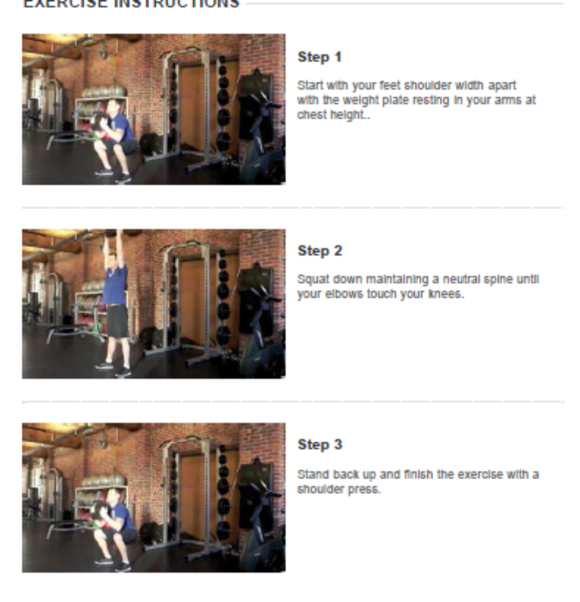
Click arrows to view more recent scores
→

Goblet Squats

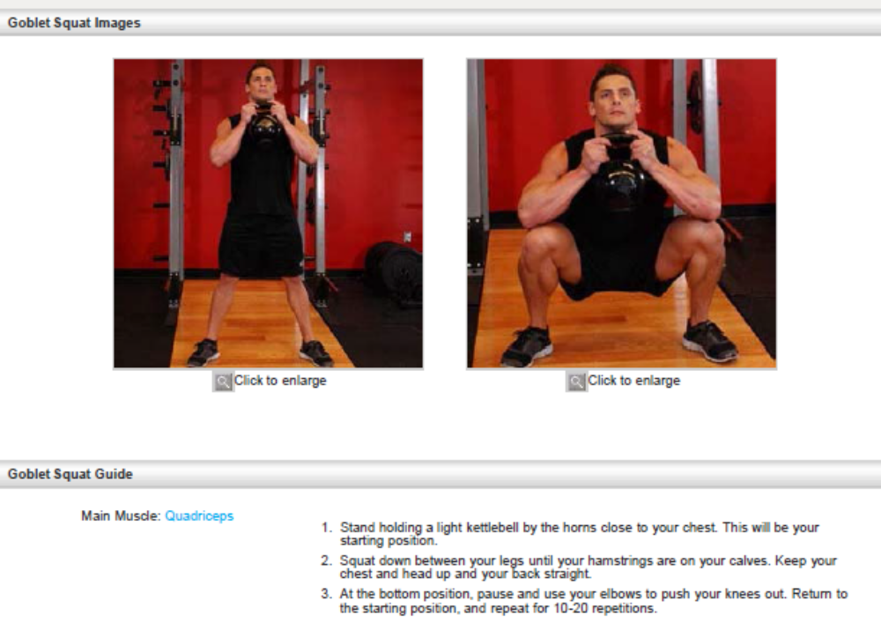

Incline Bench

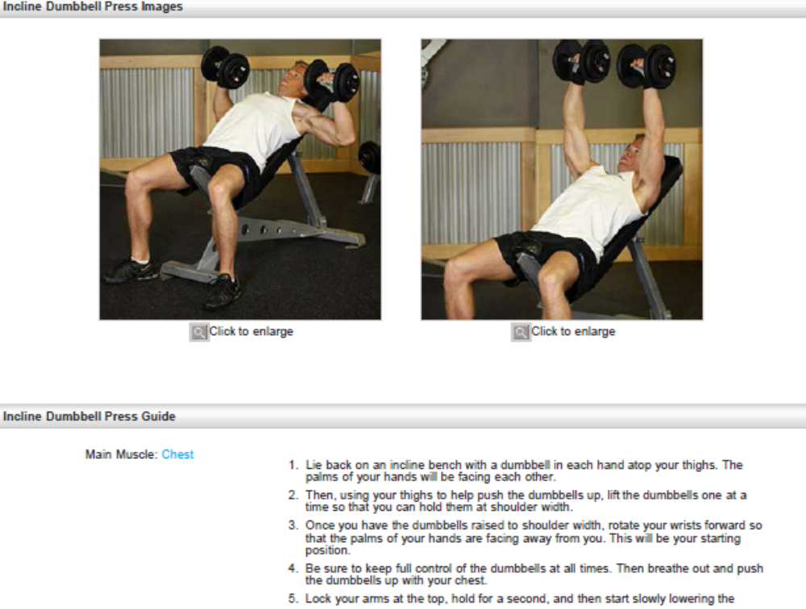

SS w/MB Seated Chest Pass

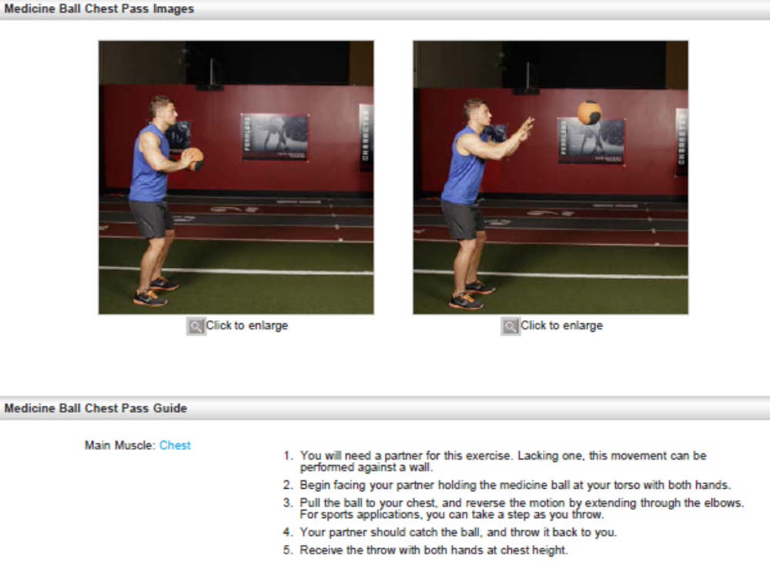
Stepups w/ DB

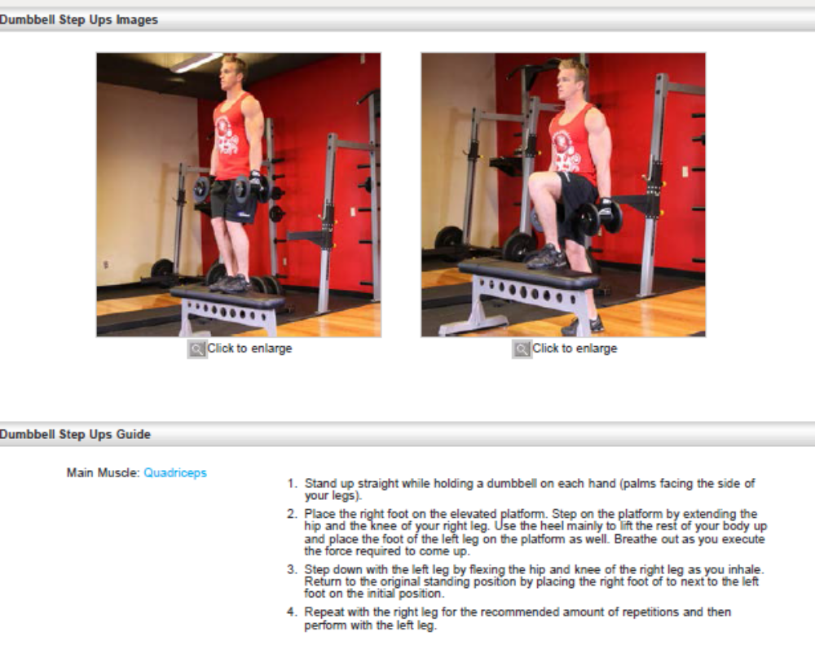

Nosebreakers

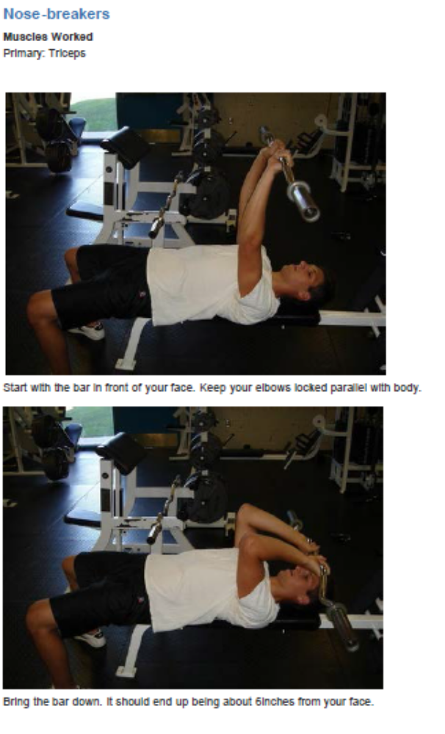

Shoulder Series (Rear Dealt, Lateral, Front, Upright Row(10/Exercise)

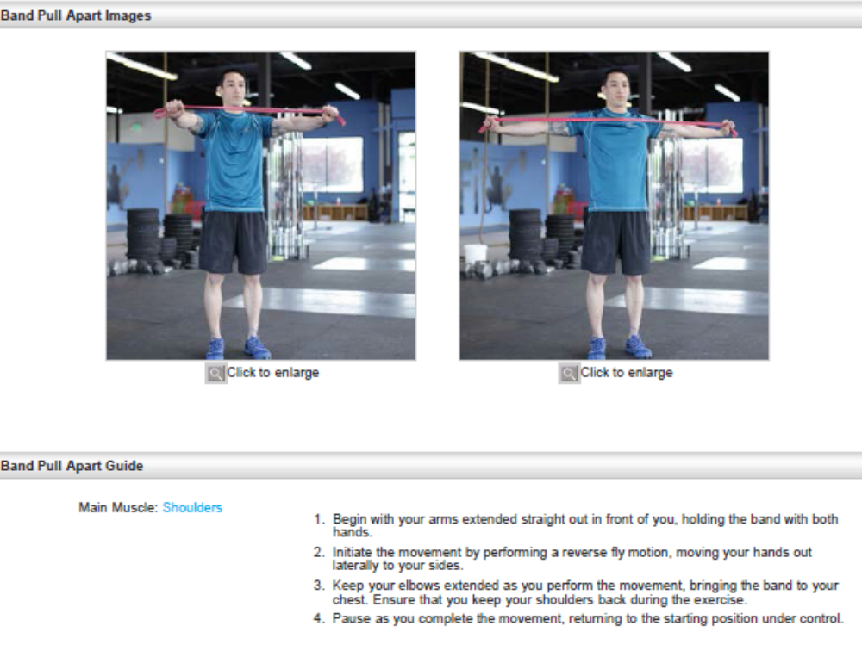
Leg Throws

Instructions
- Find a partner to help you. It doesn't require a lot of physical exertion for the partner's role, so anyone who is able to stand and has some upper body strength will do.

- Lie with your back on the floor, placing your head between
your partner's feet.

- Reach back and hold your partners ankles or calves securely with your hands. This provides leverage and stability while you're doing the exercise.

- Bend your knees slightly and slowly raise your legs towards your partner's body. Press your upper back into the floor and feel each vertebrae of your spine roll off the ground. Bring your legs all the way up so your partner is holding onto your ankles.

- Feel your partner throw your legs away and down. Your partner should not just push, but rather throw them so your legs have both momentum and gravity pulling them down to
the floor.

- Resist the force of your legs as they are thrown and don't let your feet touch the ground. Slowly bring your legs back up to your partner and allow him to grab your ankles again.

- Ask your partner to throw your legs in different directions.
Throwing them to the side at least 45 degrees works the oblique muscles and random

Side Planks



